- “EK PED MAA KE NAAM”
2. Organized by: Sat Kaival College of Pharmacy
3. Date & Venue: 29/06/2026, Herbal garden
4. Objective:
- Raise Awareness
Educate people about environmental issues such as pollution,,climate change,deforestation
- Encourage environmental protection
Motivate individuals,communities,and organization to take action to protect natural resources.
- Inspire community participation
Engage people in activities such as tree planting,clean up drives
- Support conservation efforts
Highlight the importance of protecting forests,wildlife,and ecosystem
- Promote sustainable practices
Adoption of eco-friendly habits like reduce air pollution and improve air quality

5. Number of Participants: 70
Number of Student | 50
Number of Faculty | 20
Number of external participants (if any) | 0

6. Program Schedule:
Time | Activity | Venue
10 A.M TO 11 A.M | TREE PLANTATION | HERBAL GARDEN

7. Key Highlights:
- Various saplings were planted to enhance the green environment
- Students took a pledge to protect and nurture the planted saplings
- Active participation of 50 students along with teaching and non teaching staff
- Go green
- Event concluded with a message to encourage everyone to plant and protect trees for a greener and healthier future
8. Outcomes of the Event:
Enhanced Knowledge – Increased awareness among students and staff about environment conservation
Skill Development – Promote team work,social responsibility
Increased Motivation – Inspired students to adopt eco friendly practices
Practical Exposure – Enhanced green cover on the college campus
9. Feedback Summary:
The Tree Plantation Programme held on 29.06.2026 at Satkaival College of Pharmacy was a meaningful and successful initiative. The event encouraged environmental awareness and highlighted the importance of conserving nature. Students, faculty members, and staff actively participated with great enthusiasm, making the programme both educational and inspiring. The activity motivated everyone to take responsibility for protecting the environment and promoting a greener future.

10. Conclusion & Acknowledgement:
The Tree Plantation Programme concluded successfully with active participation from all attendees. The event reinforced the message that planting and caring for trees is a simple yet powerful step toward environmental conservation. It inspired participants to continue contributing to sustainable practices and to spread awareness about the importance of preserving nature for future generations. We sincerely express our heartfelt gratitude to Mr. Mayank Bapna Sir for his valuable guidance, encouragement, and continuous support in organizing and conducting the Tree Plantation Programme on 29.06.2026 at Satkaival College of Pharmacy. We also thank the Principal, faculty members, staff, and all the students who actively participated and contributed to the success of the event. Their enthusiasm and cooperation made the programme a memorable and impactful initiative for environmental awareness.

11. Supporting Documents:
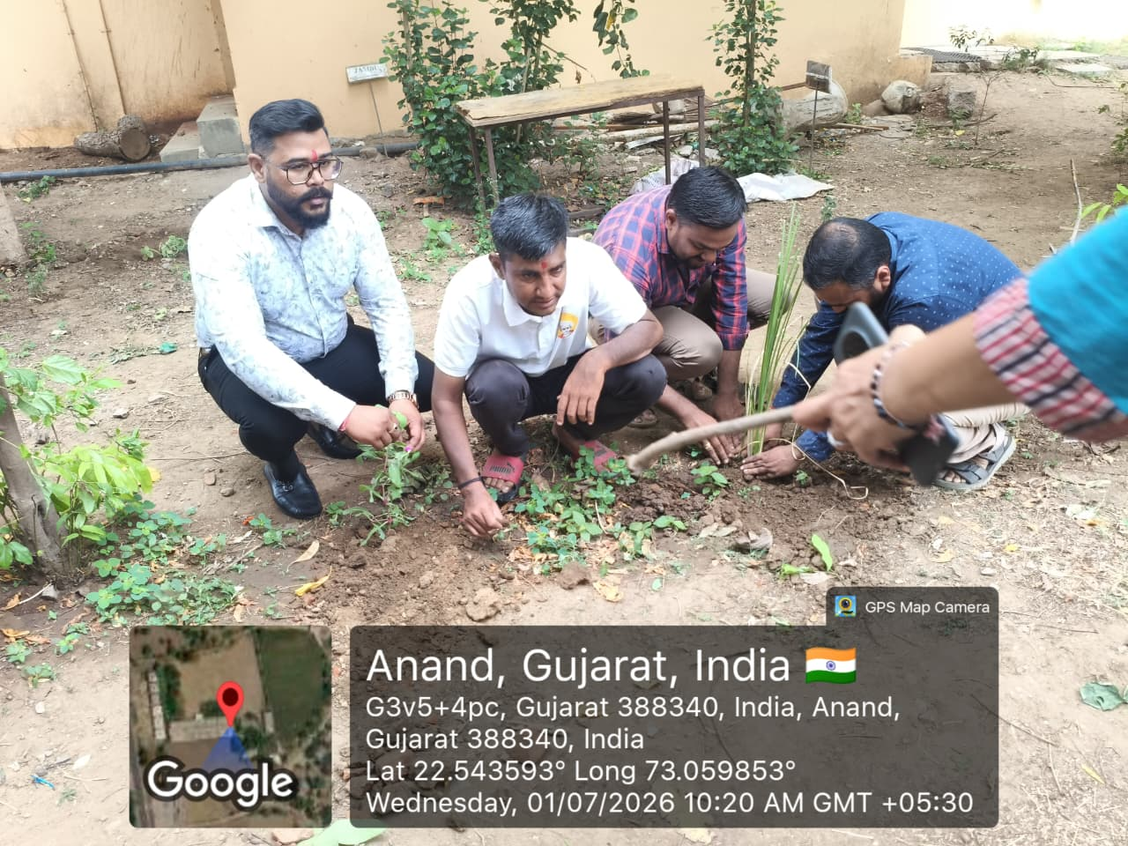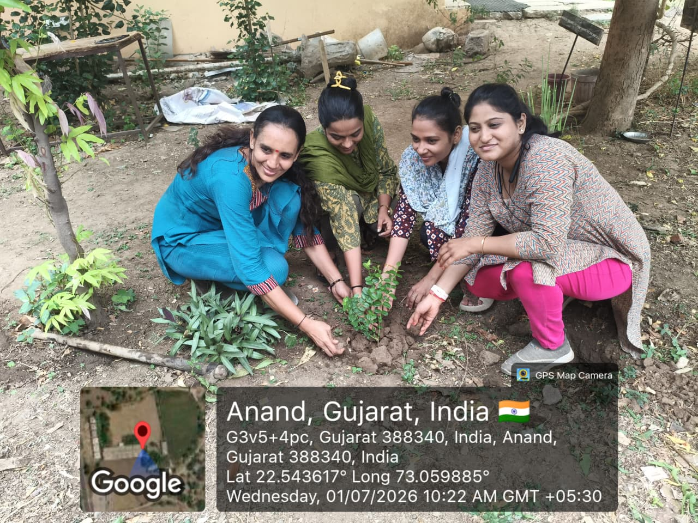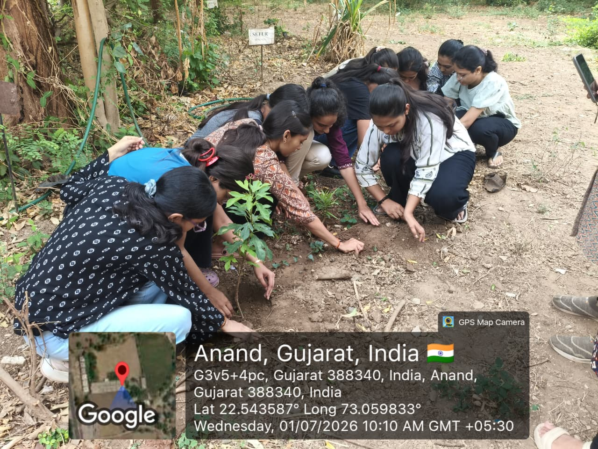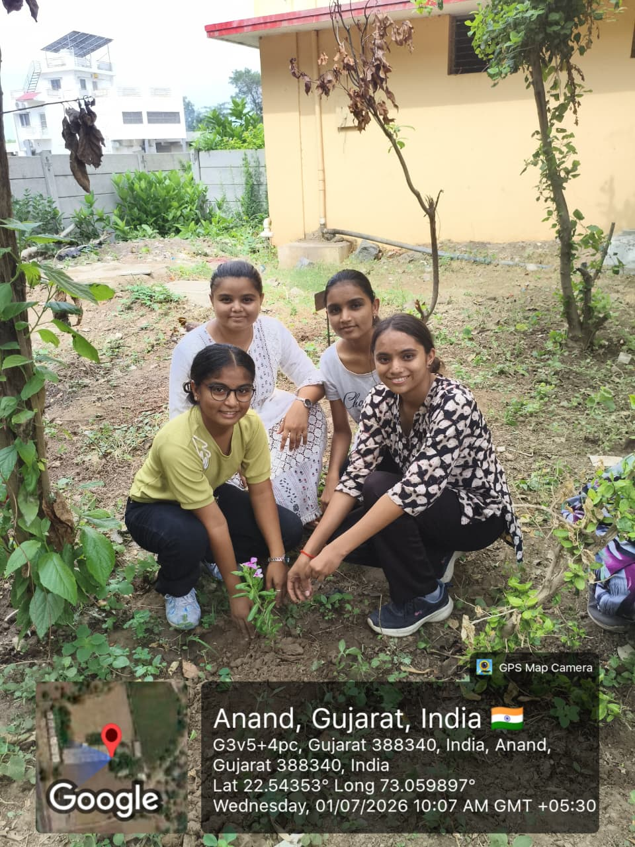

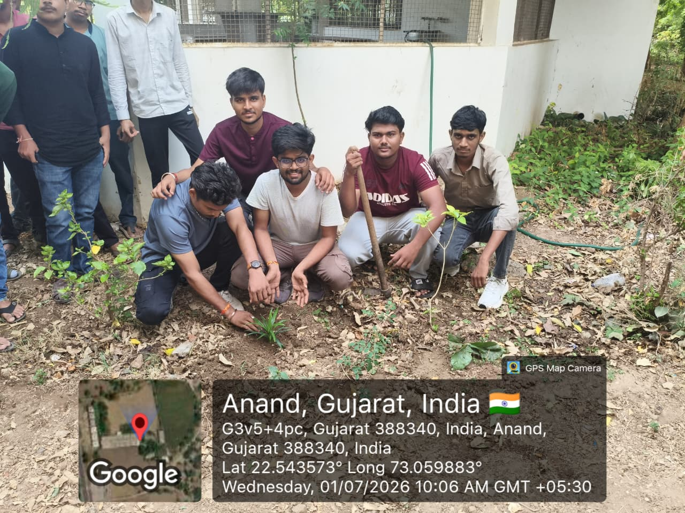

Submitted by:
Principal
SKCOP
Sejal Bhoi
Assistant Professor
1 st July 2026

